Geospatial Analysis Report: National Trends in India's Sex Ratio
Table of Contents
- Introduction: Defining Gender Equity Through Spatial Data
- Methodology: Data Integration and Choropleth Mapping
- Key Findings: The North-South Divide
- Detailed Observations: Regional Benchmarks and Disparities
- Strategic Implications for Analytics and Policy

1. Introduction: Defining Gender Equity Through Spatial Data
This report provides a macro-level analysis of India’s sex ratio, utilizing geospatial visualization to identify patterns of gender equity across the country. By moving beyond tabular data, this spatial approach reveals clear regional clusters that are vital for public health analytics and social policy planning.

2. Methodology: Data Integration and Choropleth Mapping
The analysis was performed using QGIS, integrating Census of India datasets with national state boundaries.
- Visualization Technique: A choropleth map was engineered using five distinct data classes, ranging from 774 to 1084 females per 1000 males.
- Data Classification: Higher ratios are represented by deep purple tones, while lighter shades indicate lower ratios and higher gender imbalance.

3. Key Findings: The North-South Divide
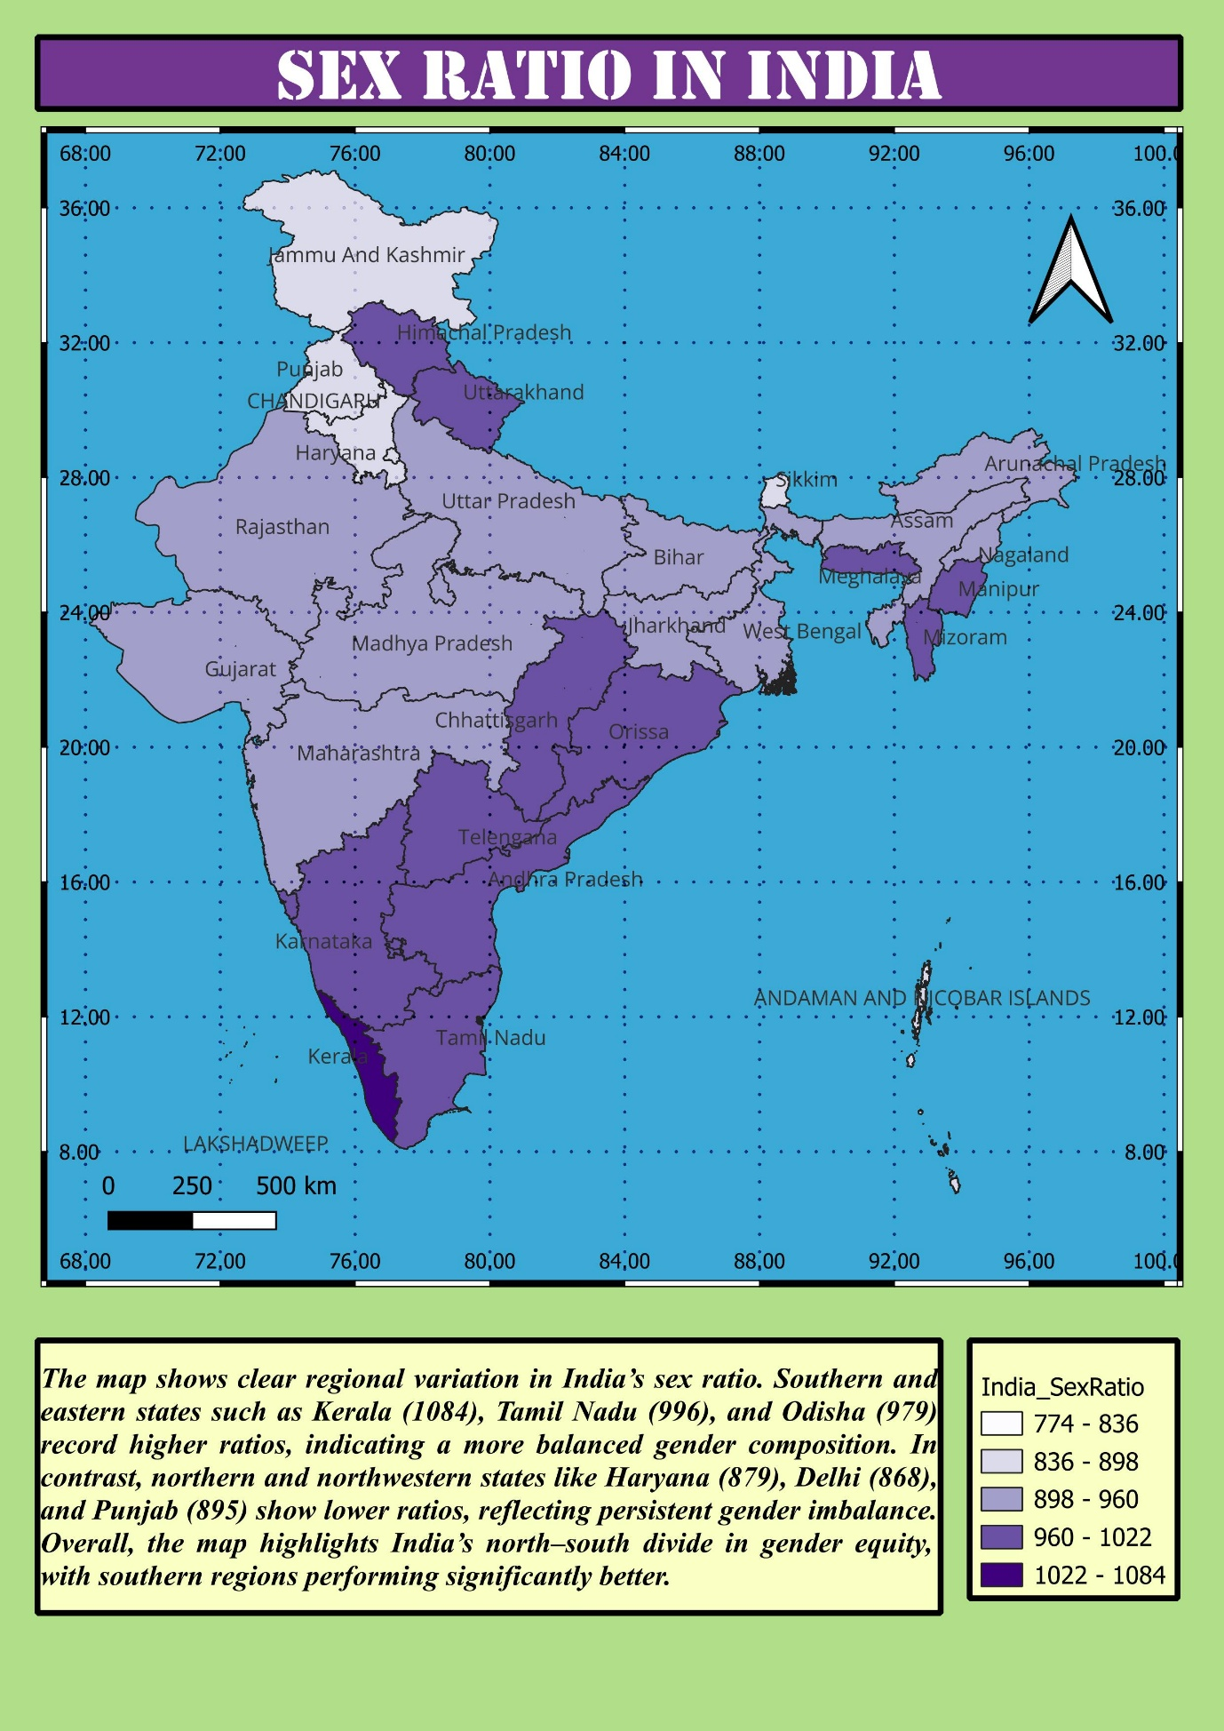
The most significant insight derived from this map is the stark North-South divide in gender composition.
- Southern Strength: The southern regions of India perform significantly better in gender equity metrics.
- Northern Imbalance: Northern and northwestern states exhibit persistent and severe gender imbalances.

4. Detailed Observations: Regional Benchmarks and Disparities
High-Performance States (Southern and Eastern)
These regions serve as the national benchmark for balanced gender composition:
- Kerala: Records the highest ratio at 1084, indicating a female-majority population.
- Tamil Nadu: Shows a strong ratio of 996.
- Odisha: Records a balanced ratio of 979.
Low-Performance States (Northern and Northwestern)
These areas show clear regional variation where ratios fall significantly below the national average:
- Haryana: One of the lowest recorded ratios at 879.
- Delhi: Shows severe imbalance at 868.
- Punjab: Records a low ratio of 895.

5. Strategic Implications for Analytics and Policy
- Targeted Resource Allocation: For healthcare and social analysts, this map pinpoints exact geographies where "Beti Bachao Beti Padhao" and similar gender-equality initiatives require the most intensive intervention.
- Sociological Clustering: The clustering of low ratios in the Northwest suggests that gender imbalance is not random but tied to regional socio-economic and cultural factors that require localized policy solutions.
- Benchmarking Success: The high ratios in Kerala and Tamil Nadu provide a spatial "success model" that can be studied to implement similar social structures in imbalanced regions.

